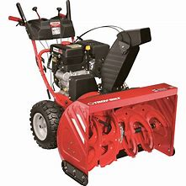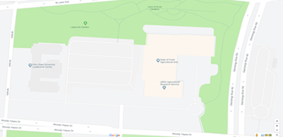
It’s hard to believe but winter is right around the corner! Before you know it, it will be time to get your snowblower out to clear your driveways and sidewalks! Although we hope winter holds off for a while, it is time to get your snowblower tuned up and ready to go for the upcoming winter season, so you can be prepared to stay ahead of the coming snow. The Agricultural Systems Management Club at The Ohio State University is holding its first-ever Snowblower Clinic to provide preventative maintenance to get your snowblower ready to go for the snow. Drop-off dates for the clinic are Monday-Tuesday, October 21-22, 2019 from 7:30-9am and 4:30-6pm. Pick-up dates are Thursday-Friday, October 24-25, 2019 from 7:30-9am and 4:30-6pm.
Cost is $40. Cash only please. No 2-stroke snowblowers please! Services Include:
- Oil Change
- Spark Plug Replacement
- Pressure Washing
- Tightening any loose bolts
Snowblowers must be in running condition to be serviced. We will not be providing any additional services at this clinic. If your snowblower needs additional maintenance, we will refer you to a local repair business. We will not accept any 2-stroke snowblowers. Only 4-stroke snowblowers will be accepted.
Drop-Off (590 Woody Hayes Drive, Agricultural Engineering Building Courtyard)
Monday and Tuesday October 21st-22nd
Times: 7:30am-9:00am, and 4:30pm-6:00pm
Pick-Up (590 Woody Hayes Drive, Agricultural Engineering Building Courtyard)
Thursday and Friday October 24th-25th
Times: 7:30am-9:00am, and 4:30pm-6:00pm
For more information and any questions please contact:
Ross Schroeder schroeder.755@osu.edu
Alex Kutz kutz.19@osu.edu
Cost: $40/snow blower. Cash only please, Credit Cards will NOT be accepted.
**We will not accept snowblowers that have 2-stroke engines. If you have to mix gas and oil or have to add a special pre mix to the fuel, these are 2 stroke engines and we will not service them. Please let me know if you have any questions regarding if your snowblower has a 2-stroke engine.

